[**T5 Online Bootcamps**](http://localhost:8888/tree/T5%20Online%20Bootcamps) **Project**

**Design**

* **Dataset Description :**

We’ll be using a real business scenario dataset related to banking from Kaggle .

The bank wants to automate the loan eligibility process (in real time) based on customer information provided while filling out the online application form. This information includes gender, educational level, dependents, income, loan amount, credit history, etc.

* **Question**

**Is the applicant eligible for the loan?**

**Data**

**Data Shape is (307511, 122)**

**Features:**

[**https://onedrive.live.com/edit.aspx?cid=c384cb7eb2ee635a&page=view&resid=C384CB7EB2EE635A!2422&parId=C384CB7EB2EE635A!101&app=Excel**](https://onedrive.live.com/edit.aspx?cid=c384cb7eb2ee635a&page=view&resid=C384CB7EB2EE635A!2422&parId=C384CB7EB2EE635A!101&app=Excel)

**Sample Data :**

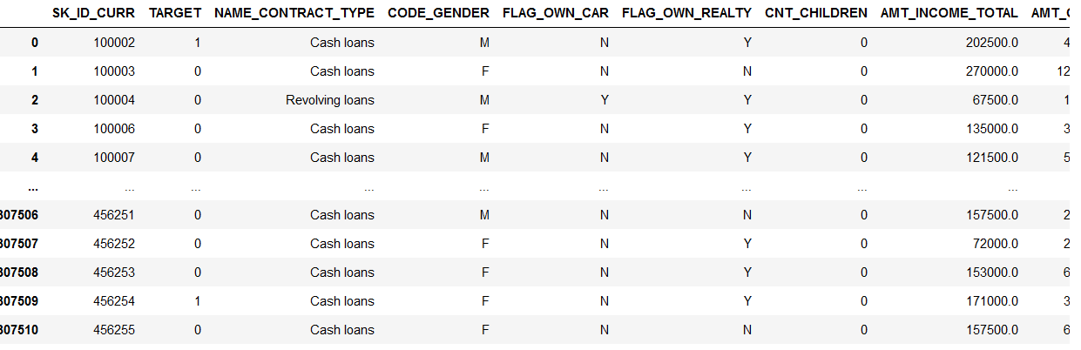

**Algorithm**

I will use the classification method - Random Forest Algorithm.

**Tools**

* Panda
* Numpy
* Matplotlib.pyplot
* Sklearn.metrics
* Sklearn.model_selection